**ASSIGNMENT --- IF ELSE , SWITCH AND TERNERY:**

1.Using ternary operator compare 3 numbers and display the smallest number

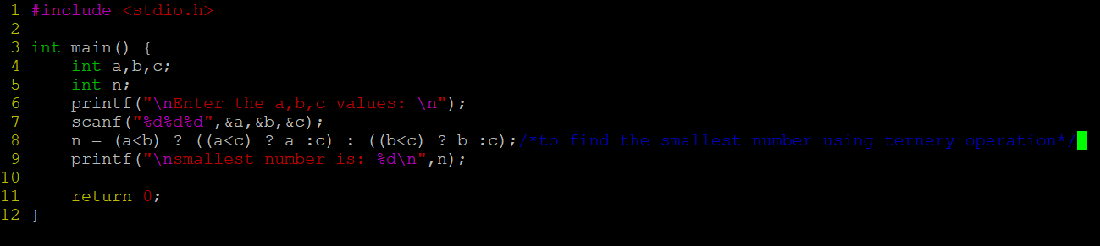

OUTPUT:

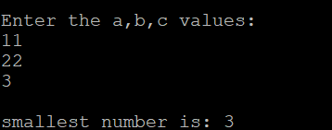

2. WAP to read a designation code and display his designation as a string. Use the following mapping.

2 – Software Developer

3 – Senior Software Developer

4 – Team Lead

5 – Senior Team Lead

anyother value – incorrect designation code

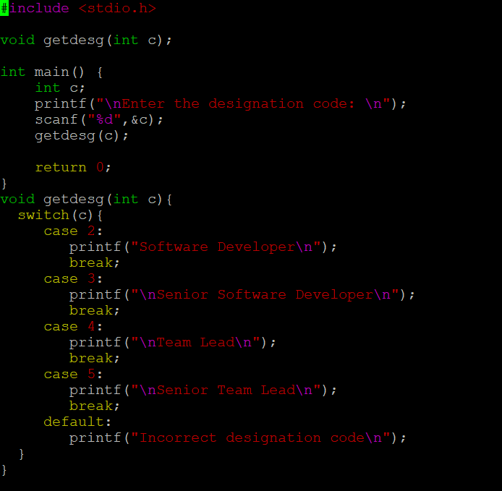

OUTPUT:

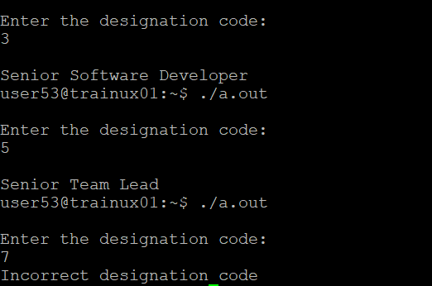

3. WAP to test the eligibility for deployment post training. Need to fulfill all the 4 conditions. Read the score inputs from user at runtime. (Use if else and switch together).

i. Test1 Score >= 75%

ii. Test2 Score >= 75%

iii. Test3 Score >= 70%

iv. Project Score >=75%

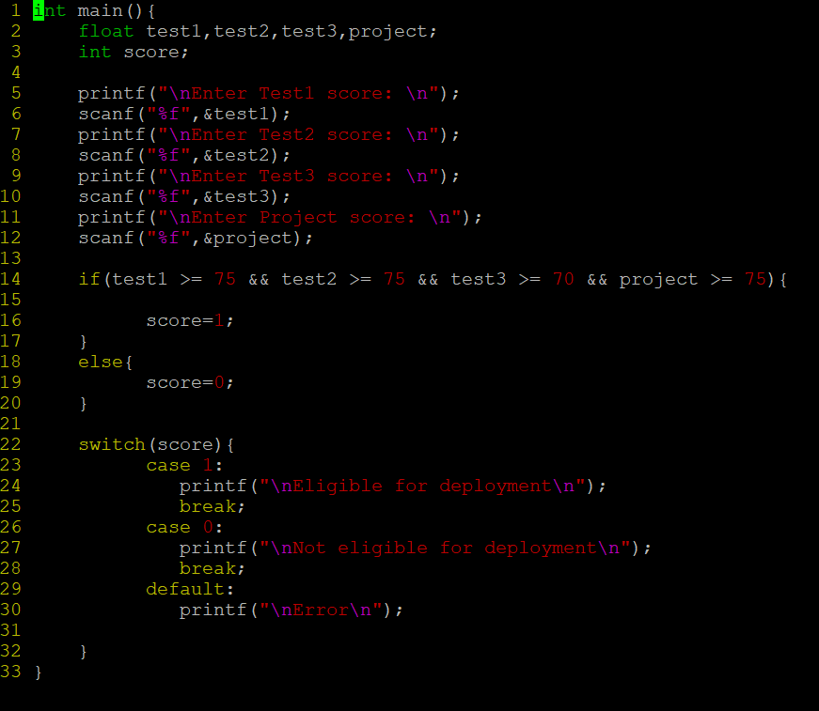

OUTPUT:

